Name: …………………………………………………… Class: ……………. ADM No. ……………..

231

Form 1
Biology
(Theory)
2 hours

FORM 1
End term I Form 1 examinations 2018

INSTRUCTIONS TO CANDIDATES:

- Write your name, class and admission number in the spaces provided above.
- Answer all the questions in the spaces provided.
- Answers must be written in the spaces provided in the question paper.
- Candidates should check the question paper to ascertain that all the pages are printed as indicated and that no questions are missing.

For Examiner’s Use Only

Question | Maximum Score | Candidate’s Score
1 – 24 | 80

This paper consists of 9 printed pages.
Candidates should check the question paper to ascertain that
all the pages are printed as indicated and no questions are missing.

© 2018 Nyakach Girls’ High school

- A form one student trying to estimate the size of onion cells observed the following on the microscope’s field of view.

- Define the term resolving power. (1 mark)
……………………………………………………………………………………………………….
- If the student counted 20 cells across the field of view calculate the size of one cell in micrometers. (2 marks)
…………………………………………………………………………………………………………
- Identify what is used for illumination of specimen under observation in an electron microscope. (1 mark)
……………………………………………………………………………………………………….
- Name the organelle that perform the functions listed below; (2 mark)
- Packages synthesized proteins.
……………………………………………………………………………………………………….
- Breakdown of worn out or damaged cell organelles and foreign particles.
……………………………………………………………………………………………………….
- Give three reasons for classifying organisms. (3 marks)
……………………………………………………………………………………………………………
.……………………………………………………………………………………………………………
……………………………………………………………………………………………………………
- What is meant by the term binomial nomenclature? (2 marks)
………………………………………………………………………………………………………………………………………………………………………………………………………………………………
- Below is a cell organelle, study it and answer the questions that follow.
N
M
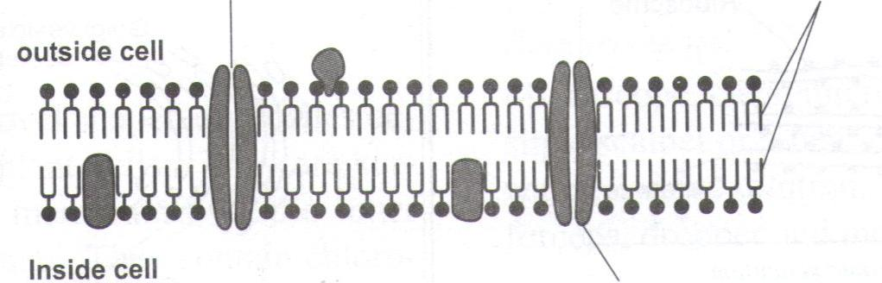
P
- Name the parts labelled N, M and P. (2marks)
N………………………………….. M …………………………………………….
- Identify the organelle. (1 mark)
……………………………………………………………………………………………………….
- Name the functions of the organelle identified in 5 (a) above. (2 marks)
……………………………………………………………………………………………………………………………………………………………………………………………………………………
- State any two functions of Golgi bodies (2 marks)
……………………………………………………………………………………………………………………………………………………………………………………………………………………………………………………………………………………………………………………………….
- The scientific name of human beings is HOMO Sapiens.
- State the mistakes in the scientific name. (2 marks)
………………………………………………………………………………………………
………………………………………………………………………………………………
- Write the name in the correct manner following the principals of binomial nomenclature. (1mark)
……………………………………………………………………………………………………….
- Identify the genus and the species of human beings. (2 marks)
Specific name …………………………………….
Genus name ………………………………………
- (a) What is a cell? (1 mark)
……………………………………………………………………………………………………….
(b) What name is given to an animal made of many cells? (1 mark)
……………………………………………………………………………………………………….
(c) Below is a specialized study it and answer the questions that follow.
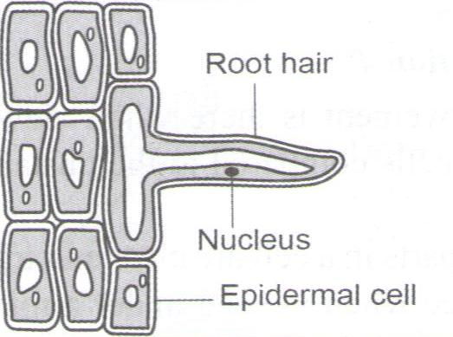
- Identify the cell. (1 mark)
…………………………………………………………………………………………………….
- How is the cell identified in c(i) above modified to its functions. (1 mark)
……………………………………………………………………………………………………
……………………………………………………………………………………………………
- State the function of the cell identified in c(i) above. (1 mark)
……………………………………………………………………………………………………
……………………………………………………………………………………………………
- Explain why it’s necessary to do the following procedures during preparation of temporary slides.
- Cover the specimen with a cover slip. (1 mark)
………………………………………………………………………………………………………..
- Stain the specimen (1 mark)
……………………………………………………………………………………………………….
- Cut thin sections of the specimen (1 mark)
………………………………………………………………………………………………………..

- What is an organ system? (1 mark)
……………………………………………………………………………………………………………
…………………………………………………………………………………………………………..
- Give a reason why scientific name are given in Latin. (1 mark)
……………………………………………………………………………………………………………
……………………………………………………………………………………………………………
- A student made a transverse section of a banana as shown below, and drew the diagram on the right.
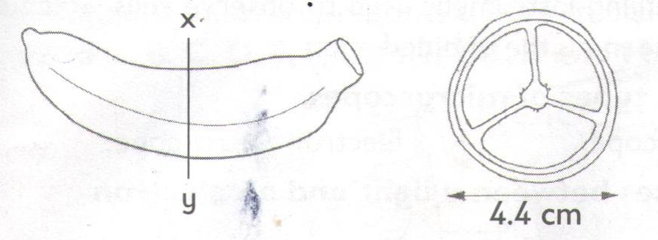
If the actual diameter of the section of the banana was 3.2cm, calculate the magnification of the drawing. (3 marks)

- State four reasons why it’s important to study Biology. (4 marks)
…………………………………………………………………………………………………………….
…………………………………………………………………………………………………………….
…………………………………………………………………………………………………………….
…………………………………………………………………………………………………………….
- Define the following sub-branches of Biology. (2 marks)
- Genetics
…………………………………………………………………………………………………………
- Ichthyology
………………………………………………………………………………………………………..

- List the differences between plants and animals. (3 marks)
Plants | Animal

- State the precautions taken during specimen collections and preservations. (3 marks)
………………………………………………………………………………………………………………………………………………………………………………………………………………………………………………………………………………………………………………………………………………………………………………………………………………………………………………………………
- List three characteristics that are common in all living organisms. (3 marks)
………………………………………………………………………………………………………………………………………………………………………………………………………………………………………………………………………………………………………………………………………………
- Name the five kingdoms of classification. (3 marks)
………………………………………………………………………………………………………………………………………………………………………………………………………………………………………………………………………………………………………………………………………………
………………………………………………………………………………………………………………………………………………………………………………………………………………………………

- Below is a diagram of the light microscope, study it then answer the questions that follow.
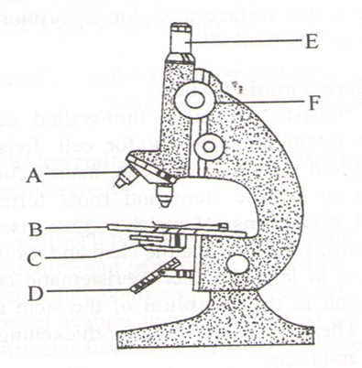
K
- Name the parts labelled A and B. (2 marks)
A ……………………………………………………………..
B ……………………………………………………………..
- State the function of the part labelled K. (1 mark)
……………………………………………………………………………………………………………………………………………………………………………………………………………………
- (a) What is a tissue? (1 mark)
………………………………………………………………………………………………………………………………………………………………………………………………………………………………
(b) Name two types of tissues in plants. (2 marks)
………………………………………………………………………………………………………………………………………………………………………………………………………………………………
- (a) What is magnification? (1 mark)
……………………………………………………………………………………………………………………………………………………………………………………………………………………………….

(b) State the differences between light microscope and electron microscope. (4 marks)
Light microscope | Electron microscope

- State two organelles found in plant cells but absent in animal cells. (2 marks)
………………………………………………………………………………………………………………………………………………………………………………………………………………………………
- The diagram below shows cell as seen under an electron microscope.
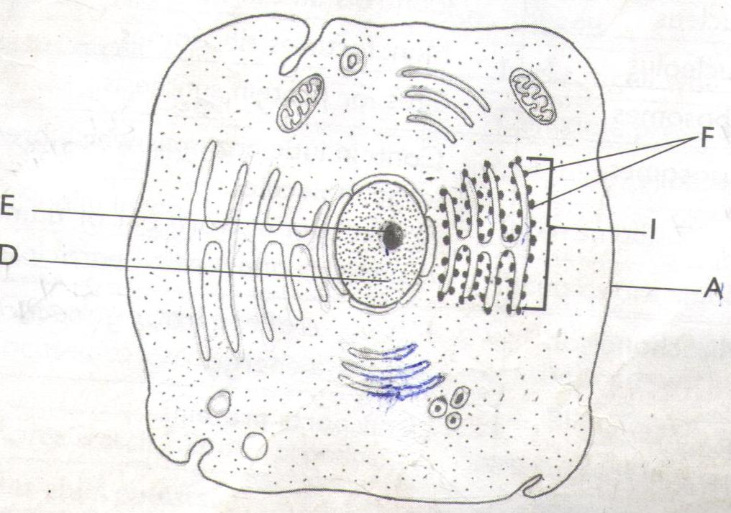
- Identify the cell. (1 mark)
……………………………………………………………………………………………………….
- Give a reason for your answer in (a) above. (1 mark)
……………………………………………………………………………………………………….
- Name the parts labelled E, F A and I. (4 marks)
E ……………………………………….. A ……………………………………….
I ………………………………………. F ………………………………………..

- On the diagram label the mitochondrion. (1 marks)
- State the function of the part labelled F. (1 mark)
……………………………………………………………………………………………………………………………………………………………………………………………………………………
- Study the apparatus below
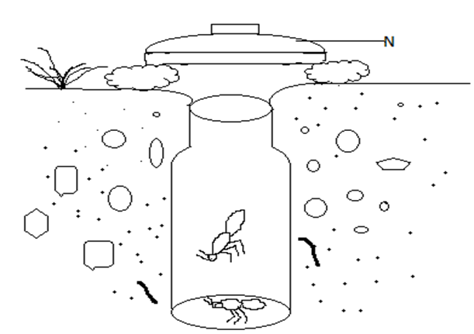
- Identify the apparatus drawn above. (1 mark)
…………………………………………………………………………………………………………
- State the function of the apparatus name in 23(a) above. (1 mark)
……………………………………………………………………………………………………………………………………………………………………………………………………………………
- (a) What is a species? (1 mark)
……………………………………………………………………………………………………………
(b) State two characteristics of organisms that belong to the same species. (2 marks)
……………………………………………………………………………………………………………………………………………………………………………………………………………………………………………………………………………………………………………………………………………...

